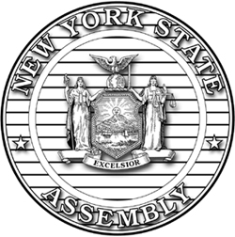
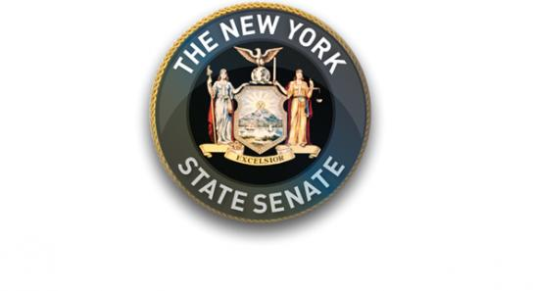

FOR IMMEDIATE RELEASE
Contact: Elizabeth Wu, Senator Stavisky’s Office— (718) 445-0004
David Ng, Assemblywoman Rozic’s Office—(718) 820-0241

Senator Stavisky and Assemblywoman Rozic Celebrate New Americans

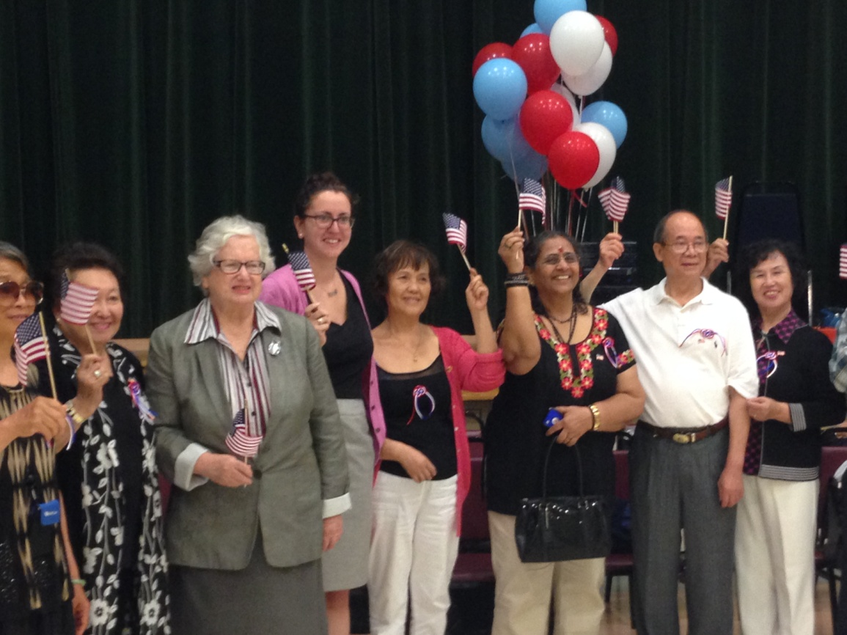

Flushing, NY—Senator Toby Ann Stavisky (D-Flushing) and Assemblywoman Nily Rozic (D-Fresh Meadows) congratulated 18 newly naturalized U.S. citizens who recently passed the naturalization test with the help of citizenship classes at the Selfhelp Benjamin Rosenthal Prince Street Innovative Senior Center.
Each newly naturalized citizen was given a citation from the Senator’s office and the Assemblywoman’s office to recognize their accomplishment.

###

