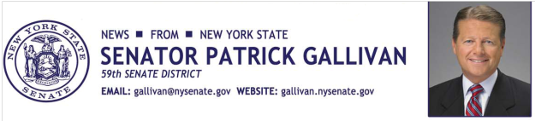

July 10, 2014
For Immediate Release
Contact: Jim Ranney
716.656.8544
716.256.9001

SENATOR GALLIVAN SPONSORS WYOMING COUNTY
BLOOD DRIVE

Unyts TO COLLECT DONATIONS AT WYOMING COUNTY COMMUNITY HOSPITAL ON JULY 23RD

Senator Patrick M. Gallivan (R-C-I, Elma) will serve as Honorary Chairman of the Wyoming County Community Blood Drive on July 23. Unyts will collect blood donations between 9:00 a.m. and 6:00 p.m. at Wyoming County Community Hospital at 400 North Main Street in Warsaw.

“The need for blood in our community is constant. By donating blood you may very well save someone’s life. Let’s make sure the supply meets the demand, because you never know when you or a loved one might need blood. I encourage everyone who can donate, to participate,” Gallivan said.

Unyts is WNY’s only organ, eye, tissue, and community blood center, and the first organization of its kind nationwide. You can schedule an appointment to donate blood by visiting www.unyts.org. Click on the “give blood” icon and enter sponsor code 3004. You can also call (585) 786-2233 extension 4467. Photo ID is required and walk-ins are also welcome the day of the event.

All donors will receive a free hotdog and a pair of tickets to an upcoming Buffalo Bisons home game.

-30-

