September 21, 2012
For Immediate Release
Contact: Marcus Povinelli (631) 585-0608 or (518) 588-5478
povinell@nysenate.gov

Senator Zeldin and NY Senate Consumer Protection Committee Hold Second Hearing on Organized Retail Crime
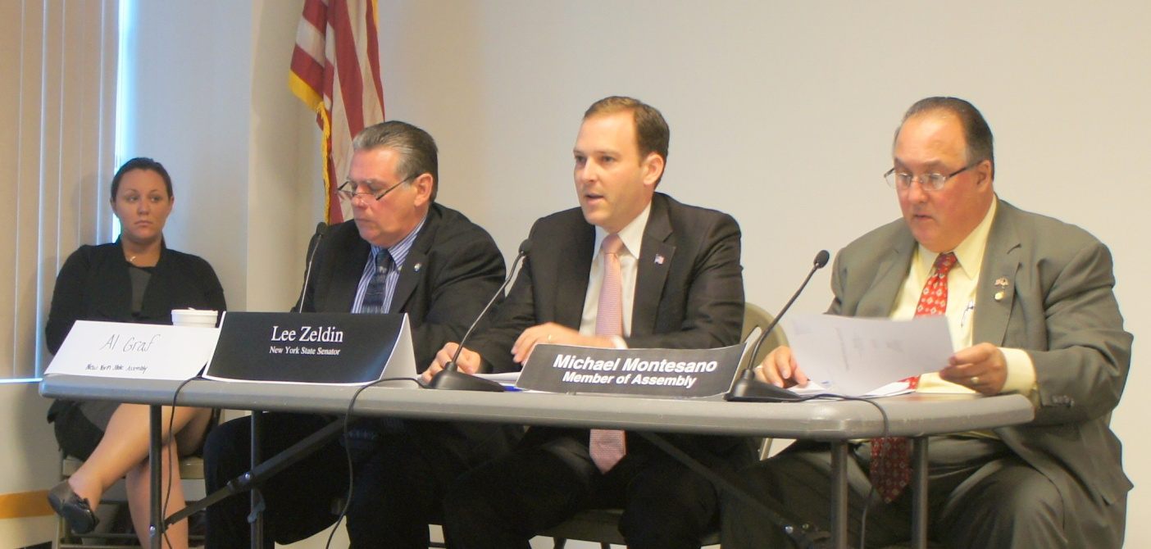

Central Islip, N.Y. – State Senator Lee M. Zeldin (R, C, I-Shirley), Chairman of the Senate Consumer Protection Committee, held his second hearing to investigate circumstances surrounding Organized Retail Crime (ORC) this past Wednesday, September 19, 2012, at the Touro Law Center in Central Islip.

The focus of the hearing was to examine methods employed by the retail industry to combat ORC and to identify solutions to better address this growing criminal enterprise throughout New York State and around the Nation.

According to the Federal Bureau of Investigation, ORC is an industry that costs United States retailers about $30 billion per year; supermarket losses account for $15 billion of this annual theft. Additionally, state and local governments are losing out on tens of millions of dollars annually in lost sales tax and excise fee revenue.

Senator Zeldin, along with Assemblyman Al Graf (R, C- Holbrook) and Assemblyman Michael Montesano (R, C, I- Glen Head), heard testimony from:
- Ted Potrikus, Retail Council of New York State Executive, Vice President and Director of Government Relations,
- Michael Rosen, Food Industry Alliance of New York State, Vice President & General Counsel,
- James D’Arcy, Security Expert for A&P, Pathmark, and Waldbaums,
- Paul Jones, Senior Director for EBay Global Asset Production,
- Justin Dietel, Security Expert for Shop Rite
- Catherine Riccards, Sr. Director of Professional Standards for Sak’s, and
- Charles Rosaschi, King Kullen’s Director of Loss Prevention.

This past June, the State Senate passed a package of five bills (S.6956-A, S.6958-C, S.6954-B, S.6957-B, and S.7370) introduced by Senator Zeldin to crack down on ORC. Assembly versions of these bills have been introduced by Assemblyman Michael Cusik (D- Staten Island).

“We must protect consumers and businesses impacted by this expanding crime network,” said Senator Zeldin. “The legislative package we passed in the Senate finally puts teeth into the crackdown on Organized Retail Crime. It is my hope that the information brought to light at this hearing will help show the need to enact these bills into law.”

“Senator Zeldin and I have introduced this legislative package of bills to tackle the growing epidemic of organized retail theft by crime rings of professional shoplifters who target retail stores in a variety of ways. These thieves are costing the industry approximately $15-$30 billion annually, which in turn means higher prices for consumers. This legislative package is a step forward to thwart these groups and individuals who are blatantly engaged in illegally obtaining retail merchandise,” said Assemblyman Cusik.

Senator Zeldin (center) is pictured here with Assemblyman Graf (left) and Assemblyman Montesano (right).

-30-

