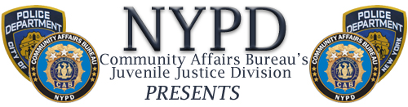
YOUTH SUMMIT
Bronx–Thursday  June 21 12pm – 2pm Fordham University  441 East Fordham Road (enter on Southern Blvd)  Manhattan North  Mon June 25 2pm – 4pm  Touro College  230 West 125th St  (enter W 124 St 7-8 Aves)  Queens South  Wed June 27 11am–1pm  York College  94-20 Guy R Brewer Blvd |  | Manhattan South  Thurs June 28 9am-11am  PS 34  730 East 12th St  Staten Island  Friday June 29 11am-1pm  St Johns University  Kelleher Bldg  300 Howard Ave  Brooklyn North  Monday July 2 11am-1pm  Woodhull Hospital  760 Broadway
The Youth Summits are being held to educate the community regarding youth crews/trends in their respective neighborhoods. Community leaders, representatives of community based organizations that deal with youth, teachers, administrators, clergy, and concerned citizens are all invited to attend.
For more information contact Juvenile Justice Division at 212-343-3707
On the WEB - www.facebook.com/NYPD or www.nyc.gov/nypd

