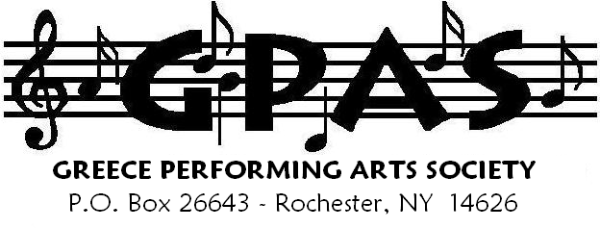
Information hotline 234-5636

GREECE CONCERT BAND, CHORAL SOCIETY AND COMMUNITY ORCHESTRA
proudly presents……

A VETERAN’S DAY
MUSICAL TRIBUTE
A MUSICAL SALUTE TO ALL THOSE WHO HAVE SERVED AND ARE CURRENTLY SERVING OUR COUNTRY!

7:15 PM TUESDAY, NOVEMBER 9TH, 2010

ATHENA PERFORMING ARTS CENTER/800 LONG POND ROAD
ADMISSION IS FREE!! (no tickets required!)

featuring….

GREECE CONCERT BAND
Under the direction of Gary J. Samulski
Special Guest Vocalist: Lisa Muldowney
GREECE CHORAL SOCIETY
Under the direction of Ralph Zecchino
Accompanist: Sandra Zecchino

GREECE COMMUNITY ORCHESTRA
Under the direction of Irina Georgieva
SPECIAL GUESTS INCLUDE:

THE AMERICAN LEGION GREECE POST 468
2009 NATIONAL AMERICAN LEGION CHAMPION &

NEW YORK STATE CHAMPION COLOR GUARD

SPECIAL GUEST “MASTER OF CEREMONIES”
MAUREEN MCGUIRE (WROC/FOX NEWS)



