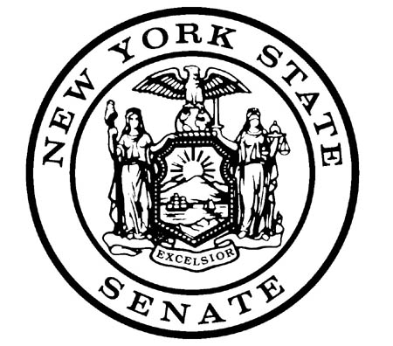

BRAD HOYLMAN
NEW YORK STATE SENATOR
27TH DISTRICT

FOR IMMEDIATE RELEASE:
August 3, 2015

CONTACT:
Peter Ajemian or Jared Odessky – (212) 633-8052

Senator Hoylman Applauds President Obama's Plan to Curb Climate Change

Calls on NYS Senate Leadership to Take Action at State Level

NEW YORK -- State Senator Brad Hoylman (D-Manhattan), Ranking Member of the New York State Senate Environmental Conservation Committee, said: “President Obama should be applauded for unveiling the strongest federal climate action plan ever proposed. The administration's new standards will aggressively cut carbon pollution, and represent the biggest step forward we have taken as a nation to combat global climate change. Here in New York, the Regional Greenhouse Gas Initiative (RGGI) has provided demonstrable proof that environmental leadership can translate into economic growth as well as critical ecological and public health benefits. In the spirit of President Obama's call to action, I urge the leadership of the New York State Senate to recognize and join the fight against man made climate change.”

