Westchester County Grandparents Coalition
Family Service Society of Yonkers Kinship Support Program
GRANDPARENT AND RELATIVE CAREGIVER FORUM
Navigating the Teen Years
Keynote Speaker
Dr. Jim Bostic, Th.D., Executive Director
Nepperhan Community Center
And
Susan Brownbill-Vega, Director of Community Affairs
Westchester County Office of the District Attorney
Thursday, November 13, 2014
9:00 am to 1:00 pm
(9:00 - 10:00 am Registration and Coffee)
Yonkers Riverfront Library
1 Larkin Center, 2nd Floor
Youth Services Information
Refreshments Served
Parking available 2 blocks south of the Library
RSVP by November 6, 2014
Carolyn Fluckinger
914-963-5118 or cfluckinger@fssy.org
Buena Vista Garage, 8 Buena Vista Avenue
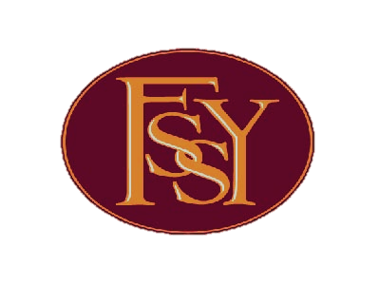
Family Service Society of Yonkers, 30 S. Broadway, Yonkers, NY 10701

