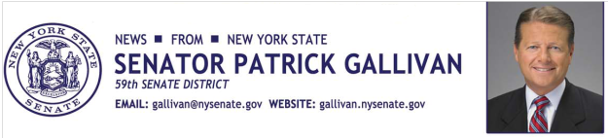
January 21, 2015
For Immediate Release
Contact: Jim Ranney
716.656.8544 or 716.256.9001

SENATOR GALLIVAN ANNOUNCES SENATE PASSES BILL TO PROVIDE TAX CREDITS FOR DONATIONS TO SCHOOLS

PROGRAM WOULD ENCOURAGE DONATIONS TO
PUBLIC AND PRIVATE SCHOOLS

Senator Patrick M. Gallivan (R-C-I, Elma) announces the New York State Senate has passed a bill (S.1976) which would provide a tax credit for donations made to public and private schools in New York, including charter schools. Gallivan co-sponsored the legislation, which would also provide tax credits for certain expenses incurred by parents who educate their children at home and qualified educators who purchase materials and supplies for classroom use.

“Providing appropriate tax credits for those who contribute to individual schools and school districts, both public and private, will result in additional resources to support quality education without increasing the burden on taxpayers. The incentive will also help the many teachers who regularly spend their own money on classroom supplies in order to help their students learn,” Gallivan said.

The Education Investment Tax Credit would also provide tax credits for donations to school improvement organizations, local education funds and educational scholarship organizations.

The legislation further provides that any donations or gifts will have no impact on the amount of state aid that a school or school district receives.

The bill will be sent to the Assembly.

-30-

