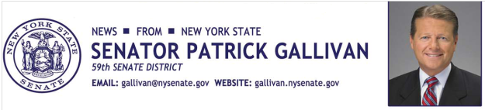

April 27, 2015
For Immediate Release
Contact: Jim Ranney
716.656.8544
716.256.9001

SENATOR GALLIVAN TO HOST
SMALL BUSINESS SUMMIT IN SPRINGVILLE

CHAMBER OF COMMERCE SPONSORS MAY 7 EVENT

Senator Patrick M. Gallivan (R-C-I, Elma) is once again teaming up with the Springville Area Chamber of Commerce and leaders in business development to present a small business summit to be held at the Colden Mill Restaurant and Banquet Facility on May 7, 2015 from 7:30 a.m. to 9:30 a.m. The event, which is free and open to the public, will focus on sales and business development.

“Our office has hosted a series of small business summits throughout the region to help those entrepreneurs looking to start their own business and those looking to grow their business,” Gallivan said. “These events are a great opportunity for business owners and their employees to learn new techniques and to share experiences and ideas for success,” Gallivan said.

Senator Gallivan is a small business owner who understands the challenges entrepreneurs face in today’s economy. He is also a member of the Senate committee on Commerce, Economic Development and Small Business and served as co-chair of a statewide committee on Regulatory Reform, working to eliminate burdensome rules and regulations that drive up business costs.

The summit will also feature Frank Swiatek, who serves as Senator Gallivan’s Senior Advisor for Small Business. Swiatek is a private sector consultant and has worked with numerous small businesses and over 25 Fortune 500 companies.

Anyone interested in attending the event can register or get more information by calling Senator Gallivan’s office at 716-656-8544.

-30-

