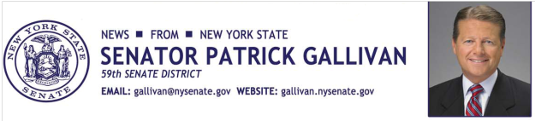
September 21, 2015
For Immediate Release
Contact: Jim Ranney
716.656.8544/716.256.9001

SENATOR GALLIVAN TO ATTEND PAPAL MASS IN NEW YORK CITY

EVENT AT MADISON SQUARE GARDEN IS PART OF POPE FRANCIS’ VISIT TO THE UNITED STATES

Senator Patrick M. Gallivan (R-C-I, Elma) will attend a Mass celebrated by Pope Francis at Madison Square Garden in New York City on Thursday, September 25 at 6 p.m. The Mass is part of the pope’s visit to the United States, which includes stops in Washington, D.C., New York and Philadelphia.

“I am honored to attend Friday’s Mass and look forward to hearing Pope Francis’ spiritual message,” Gallivan said. “I join all New Yorkers in welcoming the pope to our great state.”

Gallivan is attending the Mass as a member of the State Legislature delegation. He will travel to New York City Friday morning in time to attend the late day event.

Pope Francis is scheduled to arrive in the United States on Tuesday. While in Washington, D.C., the pope will visit the White House and will address a joint session of Congress. In addition to celebrating Mass at Madison Square Garden, the pope will also meet with the United Nations General Assembly and visit the 9/11 Memorial Museum while in New York.

Pope Francis will wrap-up his visit to the United States with a stop in Philadelphia where he will celebrate Mass at the Cathedral Basilica of Saints Peter and Paul, tour Independence Hall and visit a correctional facility.

-30-

