Amelia Sofia Ochoa Barriga
Ms. Gonzalez
Read 180
16 October 2023
My Favorite Qualities
One of the best qualities that I possess is being self-confident. What that means is that I have confidence. I like being myself and nobody else. For example, in fifth grade my mom put me in a drama club. I was scared because I thought that if I did something wrong, everybody would laugh at me. The weeks passed, and I still believed everyone would laugh at me. But then, it was the day of the performance, I decided to believe that everything was going to be okay and like I said, everything went well. I love how it went. When I think I cannot do something, I just take a breath in and out to relax myself. Everything that I have done would not be possible if I did not have my self-confidence. Looking at the smile on my family’s faces when they see me complete each goal that I propose to myself is just worth it and motivates me to keep completing goals. I hope that my parents will always be proud of who I am.
Another quality that I have is intelligence. Intelligence does not only mean being the best at everything, what it means is that you use the skills you already have to better understand something. It also means that when you are not too good at something, you go home and practice until you get it. For example, when I do not get something in class, I go home, and I try and try until I get it. I also ask for help from my teachers and parents, so they can help me understand it. This helps me in the present because on a test there might be things that I already reviewed last time. This will help me because having good grades will give me chances to go to a nicer university like Harvard and more. If I have good grades and I go to a nicer university my parents will also be proud of me.
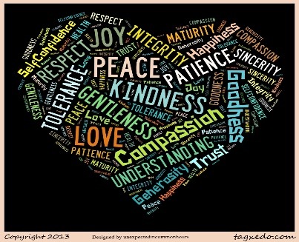
The final quality I am grateful for is my leadership skills. Having the quality of leadership makes me so proud of myself because it is so hard to have that quality. If I did not have that quality, everything would be slower because nobody is making sure they are doing the right thing. Leadership is not just being a follower or a person who tells others what it is better to do, it also inspires others to accomplish their goals. In fifth grade, I had my little group, and we always needed ideas to study better so we did not fail the class, and they would ask me to make a plan for the three quizzes. I do not know where I would be without this beautiful quality. I cannot imagine a life where nobody has leadership. In conclusion, these were the qualities that I love the most about me.

