Jalyssa Bonifacio 11/14/2023

Mvp 6-2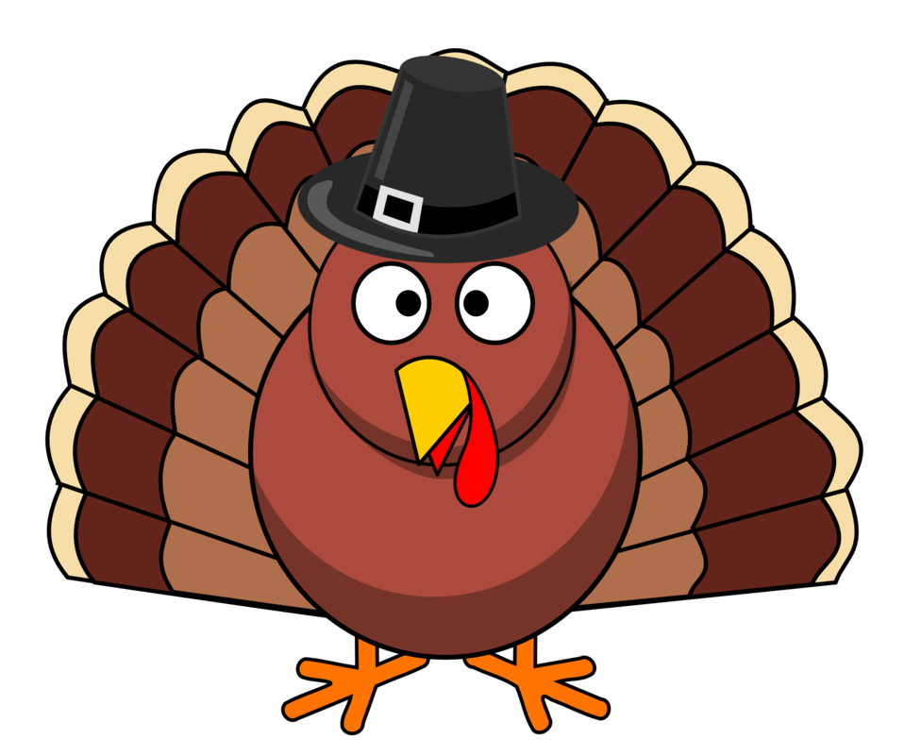

# 

# Thankfulness

### **I’m thankful for my integrity and honesty because**

### **whenever someone asks me a question I always try to respond in**

### **the nicest way possible. Whenever someone asks for my opinion**

### **on something I reply truthfully and honestly even if they might**

### **not agree with me. I always try my best to say things with honesty**

### **and a nice attitude even if that day was not so great. One time I**

### **was talking with someone and they asked me a question about**

### **their hair and it looked kinda messy so I told them and they got a**

### **bit upset but I was trying to be honest. People always tell me i’m**

### **honest and these are my reasons why i’m honest and I have**

### **integrity.**