**Kamryn Mckeithen November 13, 2023**

**Mrs. Castiglia & Mrs.Deans**

**I am Grateful**

I am thankful for my great qualities. I'm going to tell you why I'm thankful.The first quality I'm thankful for is being respectful. I'm respectful to my friends and they are respectiful to me. I am respectful to my friends, I say “thank you!.” Another quality is that I'm pretty. I am pretty on the inside and the 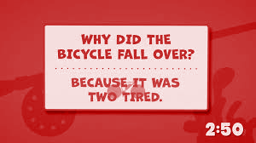outside either way! I look at myself in the mirror and my mom says I am pretty! My third quality is that I'm funny. My friends laughed at a funny joke when I fell on the floor in the bathroom! Hahah! I make jokes with Sam and Katie! I am healthy. I drink water to hydrate myself! I workout and do crossfit with Mrs.Castigila!

