**Mario Araujo November 13, 2023 Mrs. Castiglia & Mrs. Deans**

**I am Grateful for Me!**

I am thankful for my great qualities. I will tell you why I am thankful for my qualities.

The first quality is that I am smart. I am Smart because I know my times table. I know how to draw stuff. The second quality is that I am funny. I make people laugh. I say funny

words like poop, turkey poop, and fart. The third quality is

I am loving. I help people when they need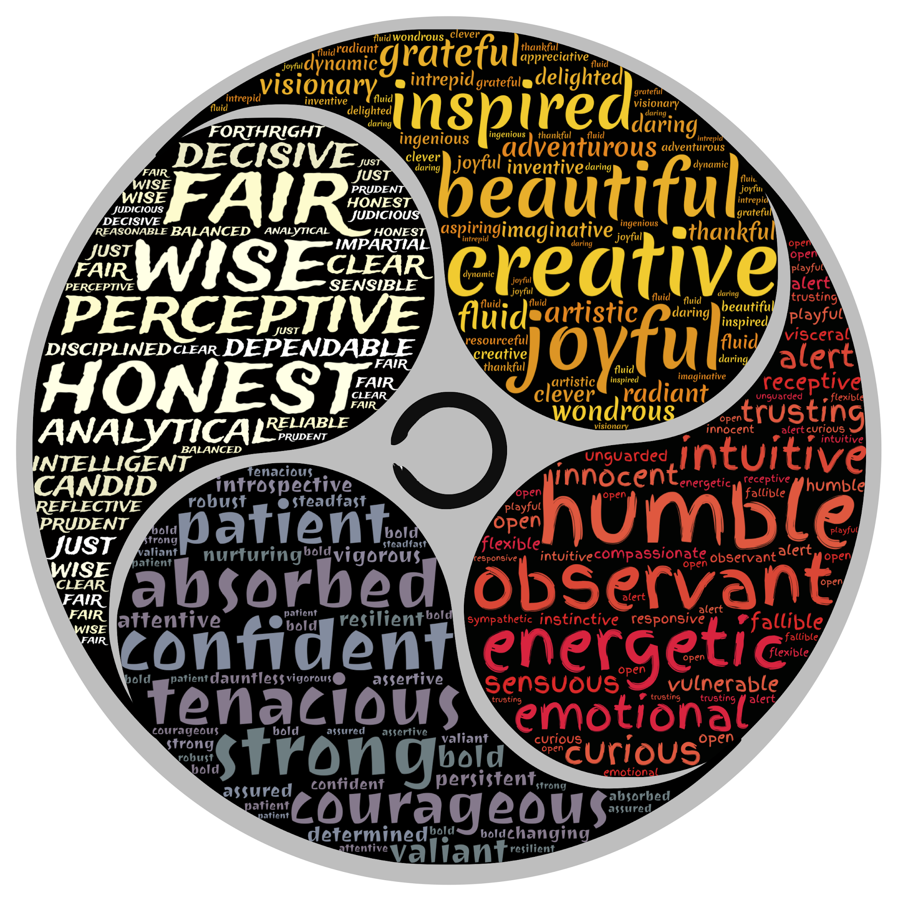

it. I am peaceful. I am calm every time I watch

tv. I like people to be quiet while I make youtube videos