Chicken Wings

[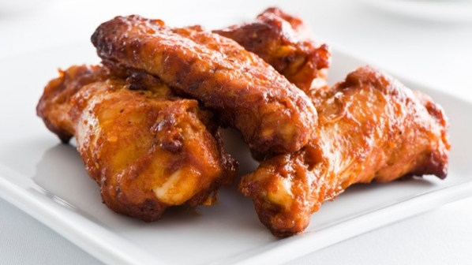](http://www.google.com/url?sa=i&rct=j&q=&esrc=s&source=images&cd=&cad=rja&uact=8&ved=0ahUKEwih7cW4lLrQAhVI5YMKHXwhC8oQjRwIBw&url=http://www.coca-colacompany.com/stories/recipes-coca-cola-chicken-wings&psig=AFQjCNGjUJlV_IN8KCYkJe5LBjGPRw20KQ&ust=1479828369131024)I have many things to be thankful for. One of them is chicken wings. That might sound strange, but have you ever stopped to think about how much we need chicken wings.

If we didn’t have chicken wings then we couldn’t eat all of the good kinds. If we didn’t have then that would be one less food we would have. Chicken wings are very good.

I think chicken wings are important because it’s very good food. They make people full. Chicken wings are good for you.

My favorite thing about chicken wings is they are very good. I eat them where ever I am I get them if there.

I hope you see why I am so thankful for chicken wings.

By Tara