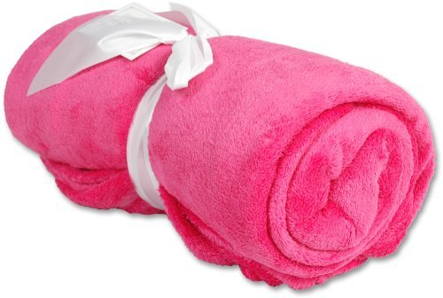
I am Thankful for Blankets

I have many things to be thankful for. One of them is blankets. That might seem strange, but have you ever stopped to think about how much we need blankets. They are sooooo fuzzy.
If we didn’t have blankets, then we would all be freezing cold. Also, everybody loves blankets. I mean who dosent?
I think blankets are important because they keep you very warm. Did you know you can get sick from not having blankets?
My favorite thing about blankets is you can cuddle with other people. Also, people will want to cuddle with you. Last, blankets can help you feel better when you’re sick.
I hope you see why I am so thankful for blankets.

By Brenna

