PS124 Jasmeet Kaur
4-206 November 9,2016
I Am Thankful For…

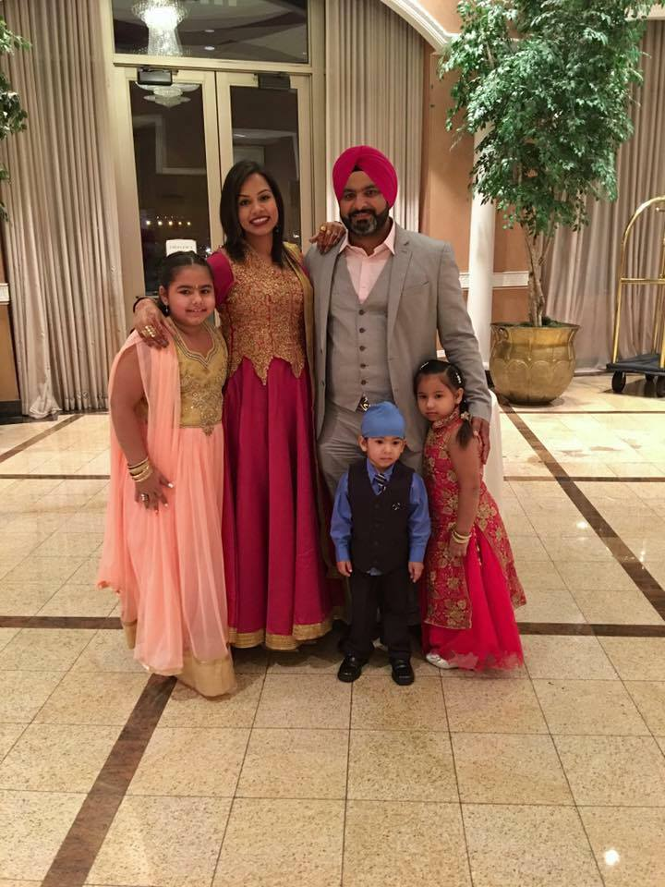
Do you know what you are thankful for? Well in this story I will tell you what I am thankful for. For an example, I am thankful for my family because they help me with every everything and love me. In my first paragraph, I will tell you what I am thankful for at home. One thing I am thankful for is my family because they help me with schoolwork, homework and by protecting me. Another thing is they give me everything I need such as clothes and food/water. What else could you ask for?!
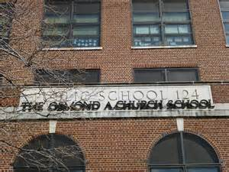
In my second paragraph, I will tell you what I am thankful for at school. My school’s name is Osmond A Church, or you can call it PS124. First, I am thankful for all the teachers I had since Kindergarten. They have worked very hard with me and have taught me very important things I need in life. Also, I am thankful for my friends. One of my best friend is Ashlyn. You no everyone need a friend or two to stand up and support them. Lastly, I am thankful for Mrs.William Jones.
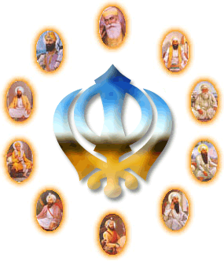
One of the most important thing I am thankful for is God! I am thankful for God because he protects my family, friends and me. Another thing why I am thankful for God is because he keeps my family, friends and me healthy. These are some of the things why I am thankful for God.
In conclusion, we all should be thankful for family, friends and God. Just remember to be thankful for what you have and not what you want. Remember the important things in your life.

