I’m Thankful for Recycling
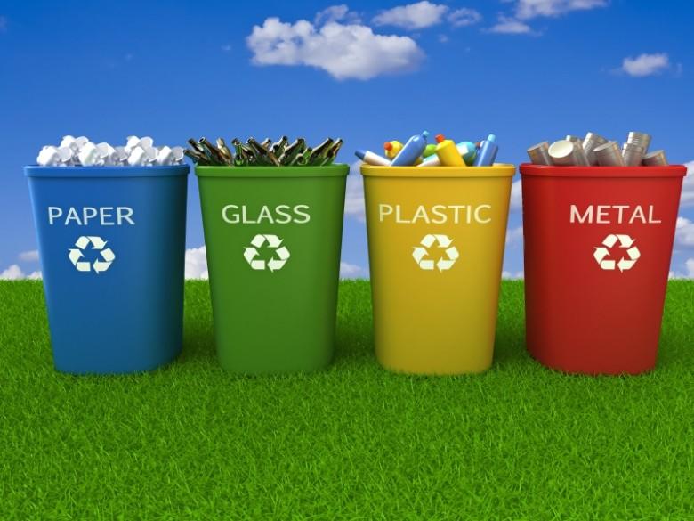
I have many things to be thankful for. One of them is recycling. That might sound strange, but have you ever stopped to think about how much we need recycling?
If we didn’t have recycling, then the Earth would not have as many trees as we have now. We would also need a lot more space for garbage dumps. Then the Earth would be dirty and not all that clean. That’s why we need recycling.
I think recycling is important because we would not be so wasteful. We also use trees to breath. If we cut down trees to make more paper instead using recycled paper or using paper that was thrown out our air can get dirty.
My favorite thing about recycling is sorting cans from paper, glass from plastic. I also like to recycle by putting old food scraps in a bucket and dumping them in the garden to use as plant food.
I hope you see why I am so thankful for recycling.
By Madison

