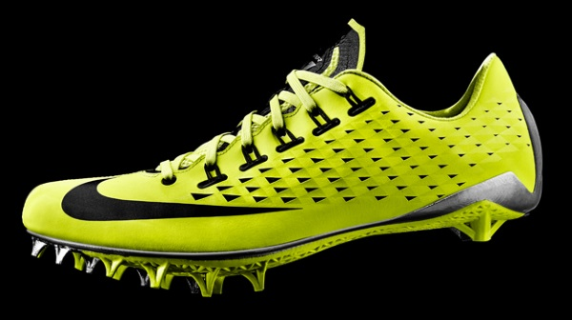
I am thankful for shoes

I have many things to be thankful for. One of them is shoes. That might sound strange, but have you ever stopped to think about how much we need shoes?
If we didn’t have shoes then our feet will have blisters. Our feet will not be colorful. Our feet might have nails in them by accident.
I think shoes are important because they protect our feet. They also can have hidden features. They can also make our feet feel awesome.
My favorite thing about shoes is the different colors and variety like sketchers/ Nike/reebok
Hope you see why I am so thankful for shoes
Maxwell Peterson

