SOCCER
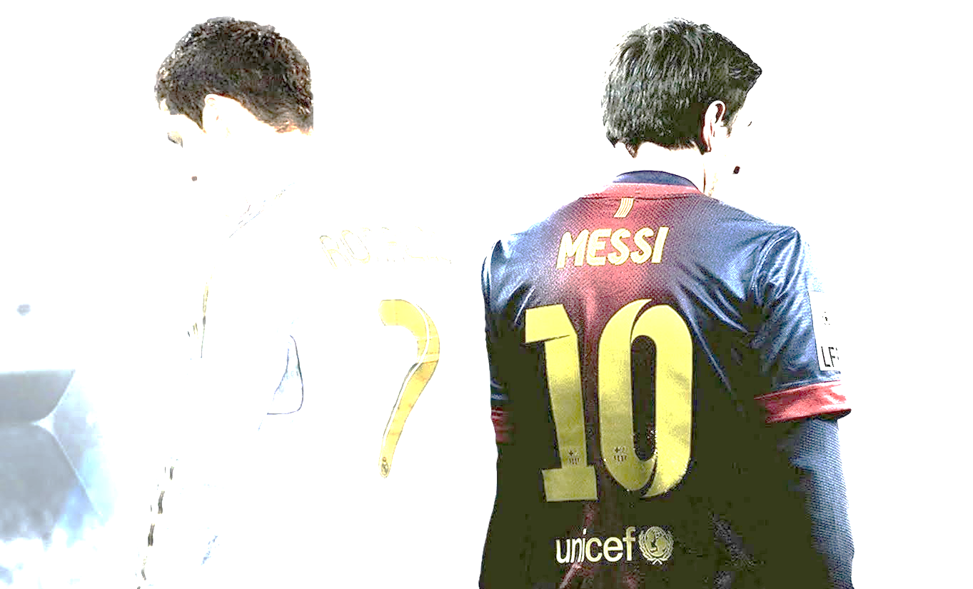
I HAVE MANY THINGS TO BE THANKFUL FOR ONE OF THEM IS Soccer.
It is a sport people in Europe love and Asia. Most soccer players like Ronaldo messi ramos neymar jr. are very good. if you try you can be on a team and can be as good as them.
Soccer can be fun to watch the world cup. maybe you ca n be a soccer player in the future IN THE WORLD CUP.
MY FAVORITE THING ABOUT SOCCER IS THE TRICKS AND MOVES. I HOPE YOU SEE WHY IM THANKFUL FOR SOCCER.
BY JASUR

