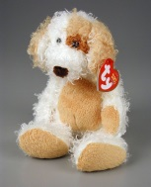
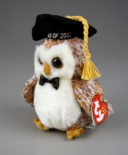
Stuffed Animals
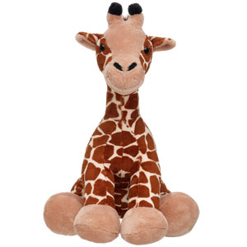
I have many things to be thankful for. One of them is stuffed animals. That might sound strange, but have you ever stopped to think about how much we need stuffed animals.
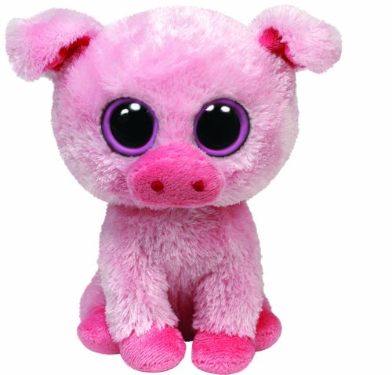
If we didn’t have stuffed animals then you could not snuggle at night. You will not be able to sleep. You would get cold at night. You would miss some one.
I think stuffed animals are important because they help you when you miss someone. They make you happy. They make it so you are not lonely.
My favorite thing about stuffed animals is they are cute. Also, fun to play with. They are amazing.
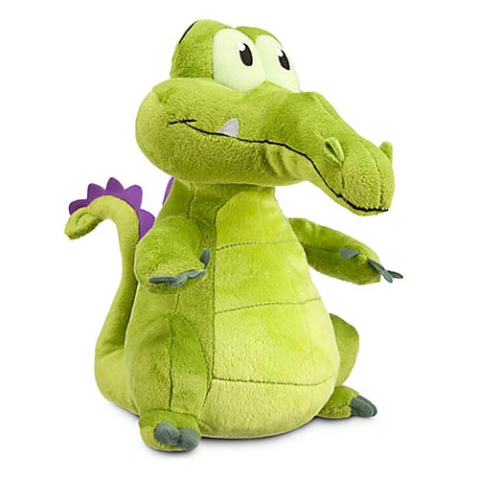
I hope you see why I am thankful for stuffed animals.

By Gwendolyn

