Thankful
Thankful for my house
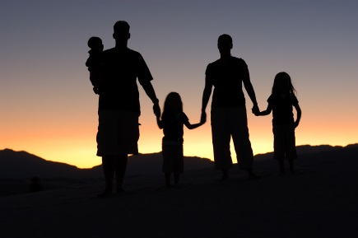
Having a family
A nice room
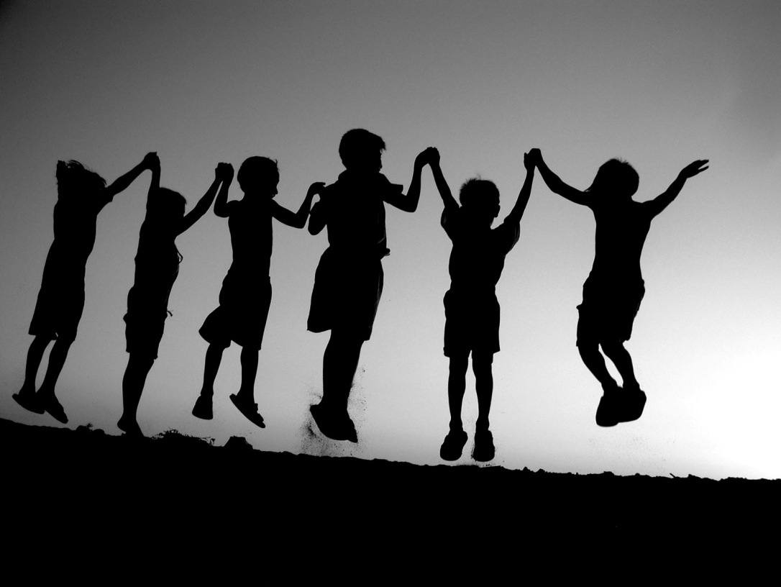
Nabors
Kind friends
For a teacher
Under armour clothes
Loving people
By: Natalie

