Thankful
Thankful for friends
Having food
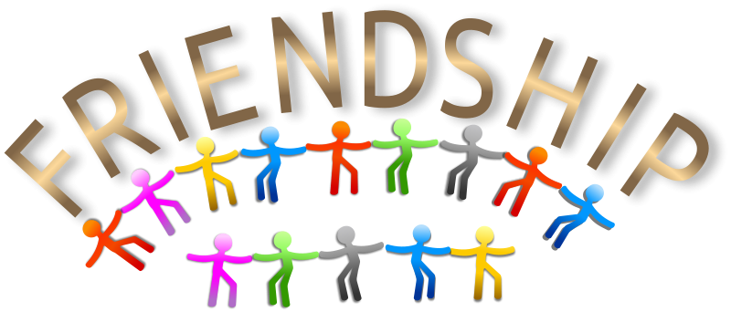
A nice house
Nice family
Kind people
For school
Usually going to school
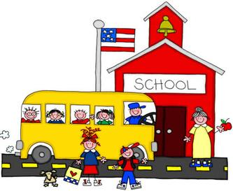
By Ethan

