Thankful

Thankful for the turkey in my stomach

Having time with my family

And the best teacher in the world

Nice people

Kind people

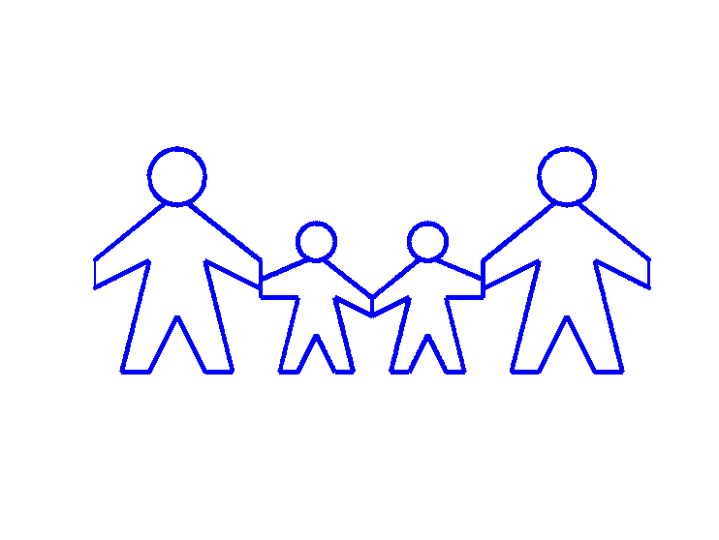For being born

Understanding family

Love family

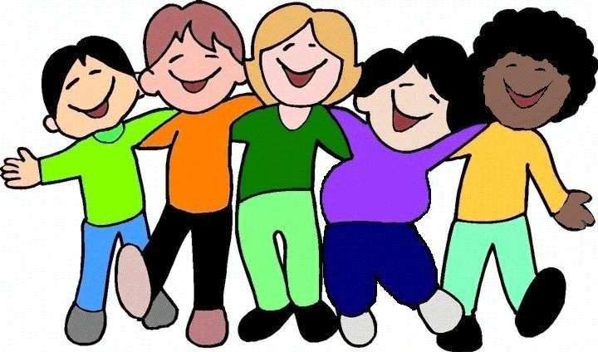From Owen