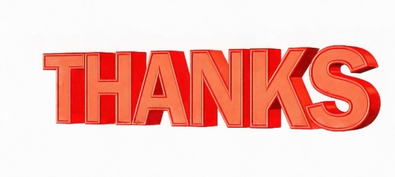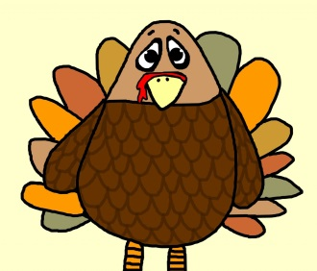Thankfulness

By: Molly Osswald

All holidays mean a lot to me but none as much as Thanksgiving when my entire family sits down together.  I am thankful for my family, friends,  and holidays.

Thanksgiving is a time of love and appreciation.  So these are the things I am thankful for about my family.  I am thankful for my brother because he is always there to play with and to talk to.  Finally he’s always there to bug when I am bored or sad.  I am grateful for my mom and dad because, they are always there to laugh with.  There always there when I don’t feel good!

I will always be appreciative of my two friends and one teacher.  I am so grateful for Miss. Drewello because she's always there to ask  question about my learning instruments.  She always helps me with my music,  and she always has a funny story ready.  I will always be  appreciative of Isabella because,  she always knows the answer when I need it most,  she helps me when I'm on crutches,  and she always knows what to say and how and how to say it. I am also grateful for Paul because,  when I walk into school he is sitting right there,  he always has a  new joke to tell,  and he always has something to laugh at.

I’m very thankful for holidays.  The three I’m most thankful for are Thanksgiving, Christmas and Easter.     I’m thankful for Christmas because I love to celebrate the season, I love the music and I love to spend time with my family, I get to see my aunt and cousin who I don’t get to see often.  I’m Thankful for Thanksgiving because I love the delicious smells of the food and the games that we play as a family when we’re all together.  Finally I love Easter because I love spring, the colors of the season and the big Easter Egg hunt at my Grandparents that happens with my entire family.

In conclusion I’m thankful for my family, friends and holidays.  I hope that every kid in the world is as lucky as I am on Thanksgiving.