Thanksgiving is a
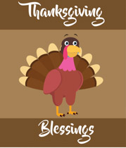
Holiday that you celebrate the thanks
And family and everyone knows
Not to be mean and instead be
Kind to others on Thanksgiving

From, Emilee Duffy
Niagara Falls, New York State Mrs. Presutti’s class
November 17, 2016

