Thanksgiving Back Then and Now
By Colby

Thanksgiving started in 1621 with the pilgrims and the Indians. The English invited the Indians to a big feast. Surprisingly they didn’t not have turkey or potatoes but had cranberries but not on stuff. One of our greatest leaders in 1789 president gorge Washington declared that thanksgiving is a national holiday
Back then they ate venison (deer meet) we eat turkey they had fish dried beans and cranberries. We eat corn and beans and maybe bread and rolls. You probably have butter and gravy too. The food we eat now is a lot different than back then like dessert. They didn’t have anything like that not even cake or sugar. Back then they hunted and gathered we just go to the store and cook. Back then they played blind man bluff and pin game, today we play board games or even video games or watch movies.

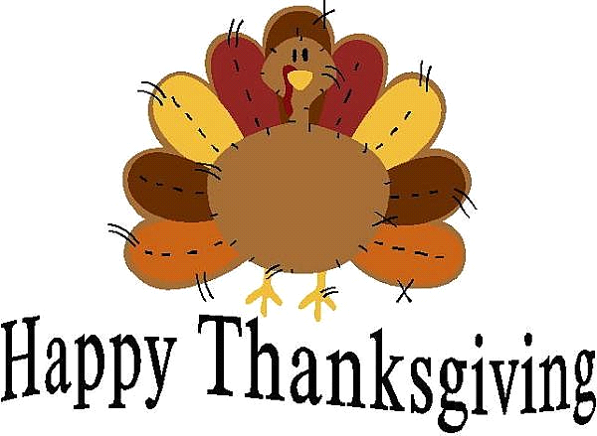
My favorite thing about Thanksgiving is eating food and turkey. My traditions are to have Thanksgiving early because my mom and I go to Florida to go to Disney. I’m thankful for my mom and my dad and my dog and also the military.

